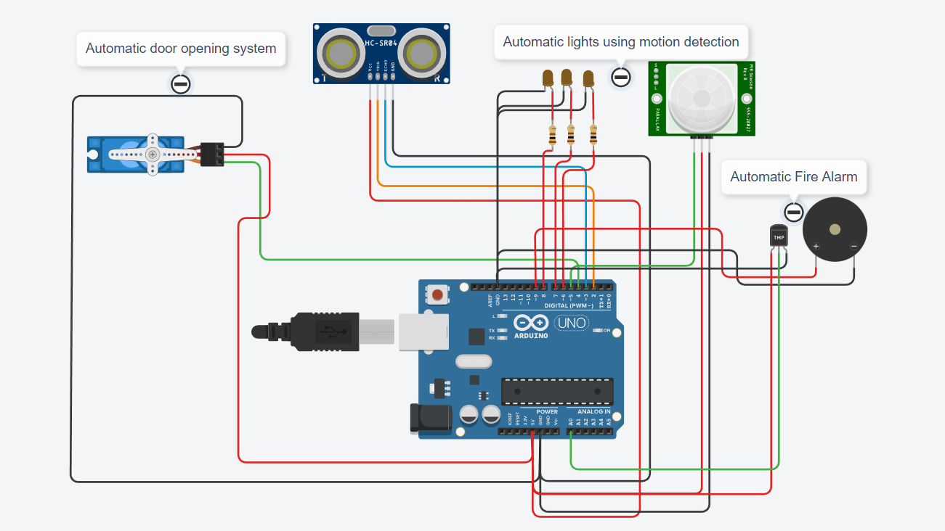**CIRCUIT DIAGRAM:**

**CODE:**

#include <Servo.h>

Servo s;

int trig=2;

int ec=3;

int PIR=5;

int led1=6;

int led2=7;

int led3=8;

int buzz=9;

void setup()

{

Serial.begin(9600);

pinMode(trig,OUTPUT);

pinMode(ec,INPUT);

pinMode(PIR,INPUT);

pinMode(led1,OUTPUT);

pinMode(led2,OUTPUT);

pinMode(led3,OUTPUT);

pinMode(buzz,OUTPUT);

s.attach(4);

s.write(0);

digitalWrite(led1,LOW);

digitalWrite(led2,LOW);

digitalWrite(led3,LOW);

}

void autodoor()

{

digitalWrite(trig,LOW);

digitalWrite(trig,HIGH);

delayMicroseconds(10);

digitalWrite(trig,LOW);

float duration = pulseIn(ec,HIGH);

float dist = (duration*0.0343)/2;

//Serial.println(dist);

if(dist<100)

{

open();

}

}

void open()

{

for (int i=0;i<=90;i++)

{

s.write(i);

delay(100);

}

delay(5000);

for (int j=90;j>=0;j--)

{

s.write(j);

delay(100);

}

}

void autolight()

{

int p = digitalRead(5);

if(p)

{

digitalWrite(led1,HIGH);

digitalWrite(led2,HIGH);

digitalWrite(led3,HIGH);

delay(5000);

digitalWrite(led1,LOW);

digitalWrite(led2,LOW);

digitalWrite(led3,LOW);

}

}

void firealarm()

{

double a = analogRead(A0);

double t = (((a/1024)*5)-0.5)*100;

Serial.println(t);

if(t>60)

{

tone(buzz,20000);

delay(10000);

noTone(9);

}

}

void loop()

{

autodoor();

delay(1000);

autolight();

delay(1000);

firealarm();

delay(1000);

}

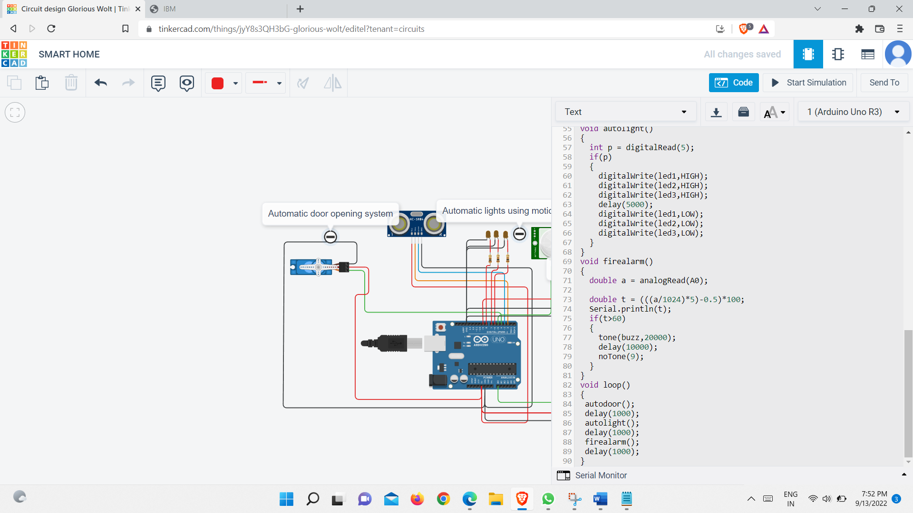

LINK TO THE PROJECT:

https://www.tinkercad.com/things/jyY8s3QH3bG-smart-home/editel?sharecode=hGpJq52OaS_iGMtREQza2d6QW9xbI5FLgMEm5zuKFIs